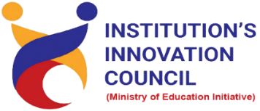
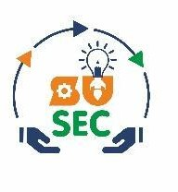

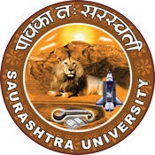
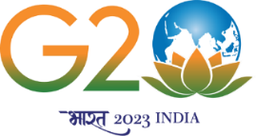
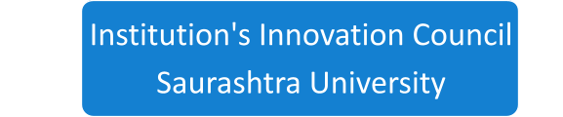

Visit to Endoc Lifecare Pvt. Ltd.

3rd August 2023

Endoc Lifecare Pvt. Ltd.
Industrial Area, Shapar
Rajkot

Contents
Saurashtra University – IIC 3
Event Schedule 3
Event Registration Link 3
Brief about Event 4
Key Points 4
Outcome 5
Connect Us: 7

Saurashtra University – IIC
The university is dedicated to instruction, research, and extending knowledge to the public (public service). Ministry of Education (MoE), Govt. of India has established ‘MoE’s Innovation Cell (MIC)’ to systematically foster the culture of Innovation among all Higher Education Institutions (HEIs). The primary mandate of MIC is to encourage, inspire and nurture young students by supporting them to work with new ideas and transform them into prototypes while they are informative years. Saurashtra University is one the Organization that have constituted the IIC to foster the vision of MoE and be a part for the promotion and development of innovation ecosystem.

Event Schedule

Event Registration Link

bit.ly/SUSEC-ENDOC

Brief about Event
SU Start-up and Entrepreneurship Council and IIC Saurashtra University in collaboration with the Department of Pharmacy organized a visit at " Endoc Lifecare Pvt. Ltd. " on 3rd August 2023. 64 students including with staff members for visit. Endoc Lifecare Pvt. Ltd is pharmaceutical company. Department of Pharmaceutical Sciences, Rajkot had arranged an industrial visit for B. Pharm 3rd year & M. Pharm 2nd year students on 3rd August, 2023 at Endoc Lifecare Pvt. Ltd. They reached at 09:30 am at Endoc Lifecare Pvt. Ltd. Students were firstly introduced to Factory by Dr. S. D. Sorathiya, Dr. V.B. Patel, Mr. L. D. Patel and Mr. Dharmesh. Then Students had breakfast there. Then divided into three groups for visit. Industry specialized in preparations of raw materials for Ornidazole, Fluconazole, Glimepiride, Tizanidine HCL, and Fluconazole intermediate. Students visited to production plant, where they were given information about Glass Line, SS-reactors and many other equipment present.

Then they taught about different color codes in the utility area. Also, they give knowledge about instruments like centrifuge, sparkler, MS-GLR reactor, utility area, diesel generator, MEE (Multi- Effect Evaporator) with the help of this, they reuse and recycle the waste liquid, restore the water from water Mother Liquor and again use for cooling tower in a condenser. Then students reached powder processing area. Powder is processed there firstly by mixing process by blender, thereafter size reduction if necessary and then powder is packed in container and transferred to the storage area.

Then visited to Research and Development Department where small-scale preparation of powder can be done and which carries out new drug discovery and development. After that visited QC and QA departments where various instruments were present like a magnetic stirrer, LOD, GC, HPLC, Milli-Q-water purification, Microbiology lab, Osmometer, UV spectrometer and other several instruments. He also answered various queries from students during the visit. The students went through raw material storage area, production area, packaging area, dispatch area etc. The visit concluded by noon.

The visit to Endoc Lifecare Pvt. Ltd was really helpful for students in their career enhancement.

Key Points

During the session, below mentioned points were discussed:

- Industry specialization
- Visit to production plant visit
- Visit of powder processing area
- Visit research and development department
- Learned about different color code in the utility area
- QC, QA department and facility tour
- FAQ related to Endoc Lifecare Pvt. Ltd

Outcome

As per the visit, students had learned about new things and divided into three groups for the visit. The industry specialized in preparing raw materials for various pharmaceutical products. Students visited the production plant and received information about equipment. Students were informed about different color codes in the utility area. The groups visited the powder processing area, where powder was processed through mixing, size reduction, and packing. Students toured the research and development department; the visit was particularly beneficial for students' career enhancement. This industrial visit provided students with practical insights into pharmaceutical manufacturing processes, quality control procedures, research and development activities, and the overall operations of pharmaceutical companies.

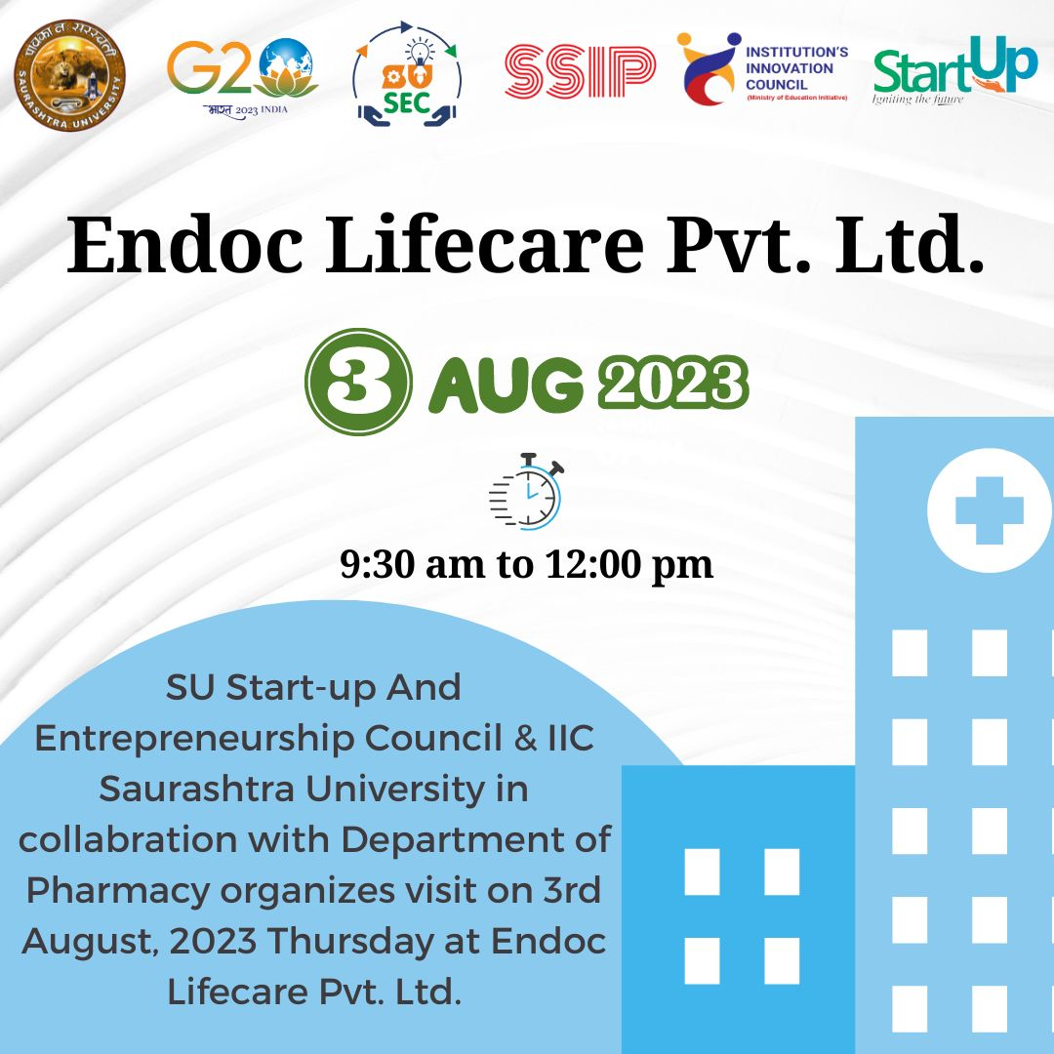

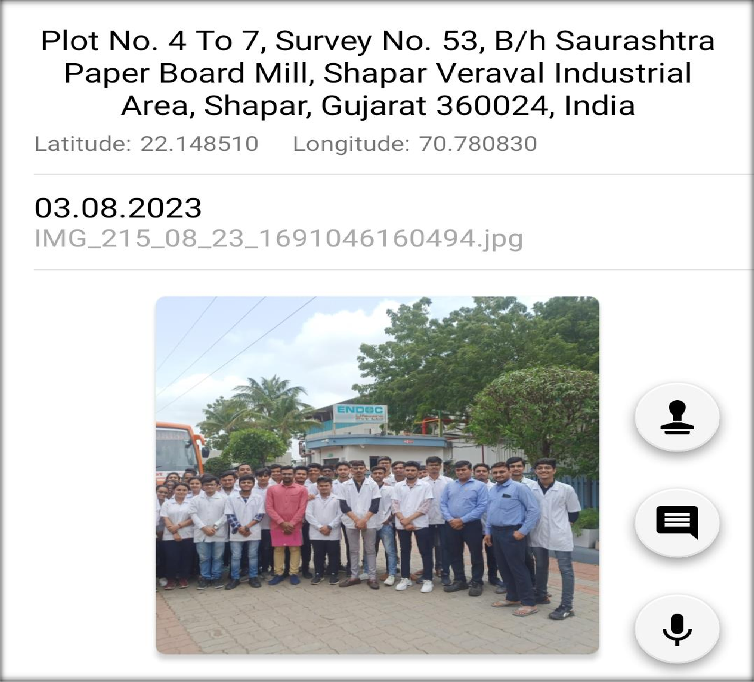

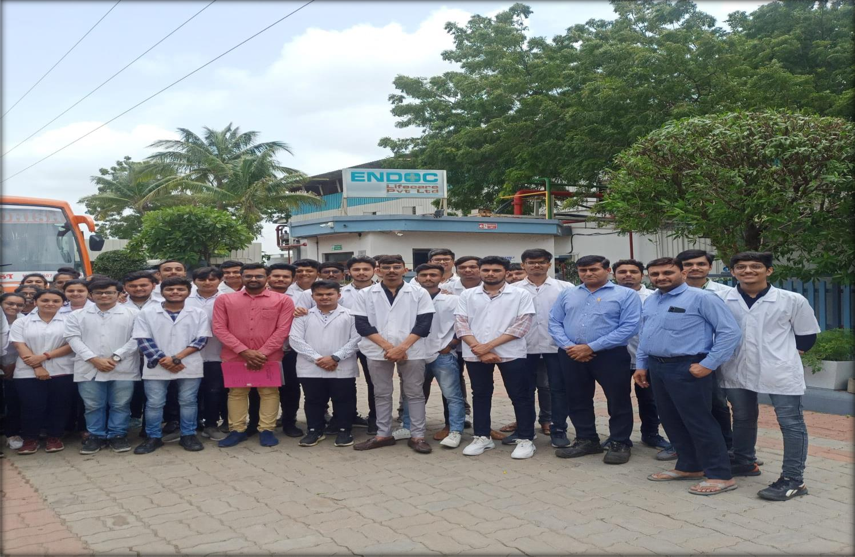

Connect Us:

https://www.linkedin.com/company/susec iic@sauuni.ac.in
https://www.facebook.com/iicsauuni https://bit.ly/SUSECLocation
https://www.instagram.com/susecrajkot https://bit.ly/SUSEC-youtube

